**STRUCTURAL DESIGN PATTERN**

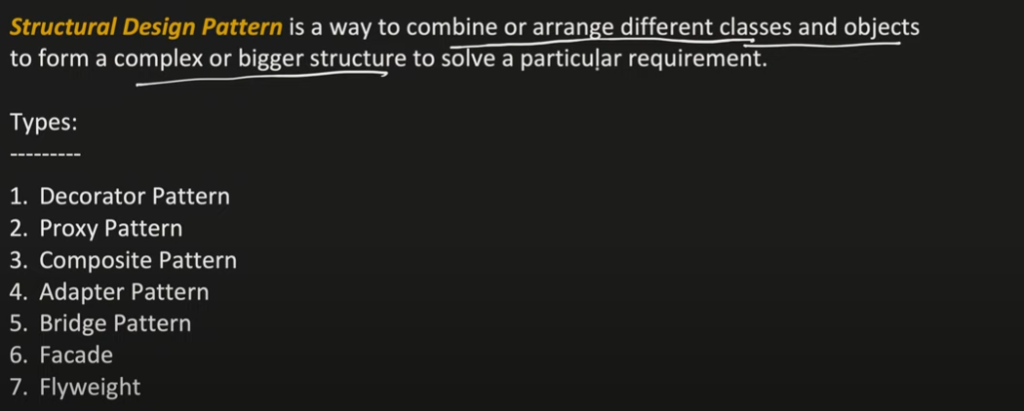

**Decorator Pattern  
  
Open to extension but close to modification**  
  
We have a has-a reln betwn ToppingDecorator and abstractPizza because inside ExtraCheese class it has a BasePizza.

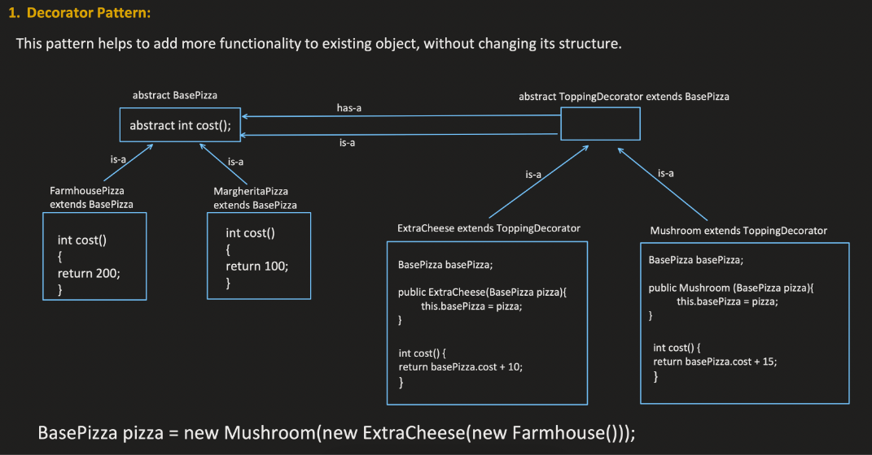

**Proxy Pattern**

This pattern helps to provide control access to original obj. Here you can see that when we want to call the create() method of EmployeeDaoImpl , we cannot call it directly but with the help of EmployeeDaoProxy

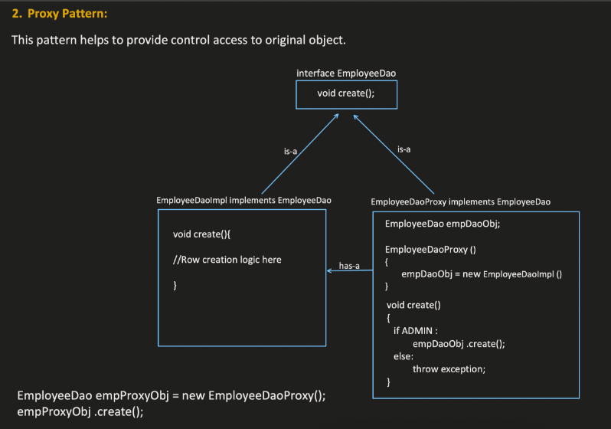

**Composite Pattern**

This pattern helps in scenarios when we have object with an object.

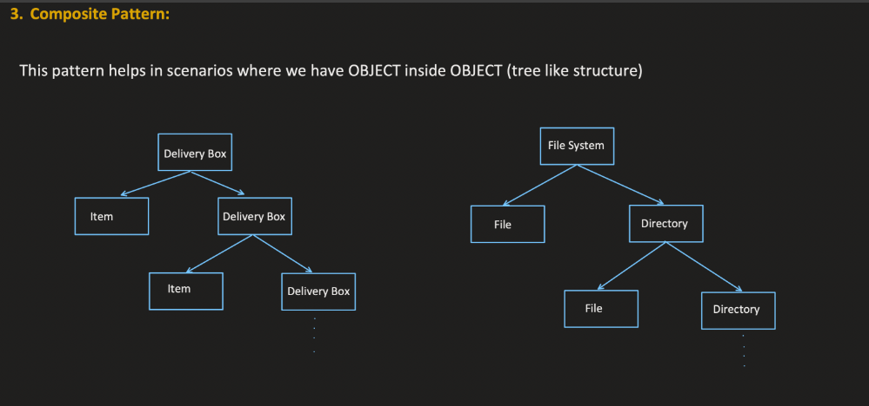

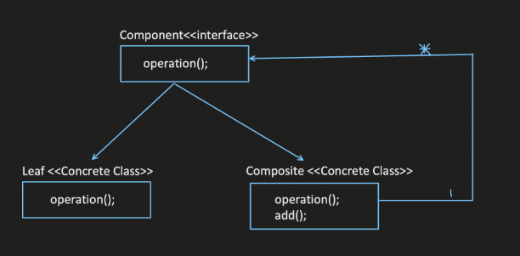

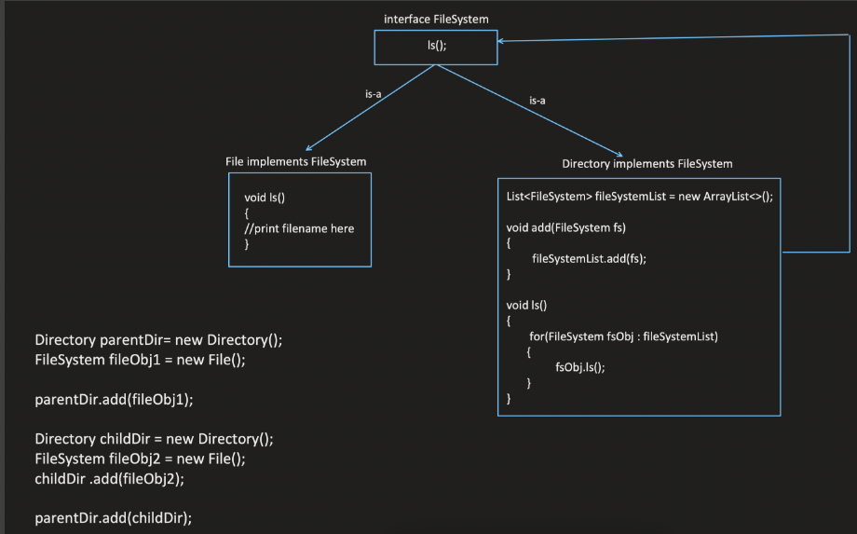

**Adapter Pattern**

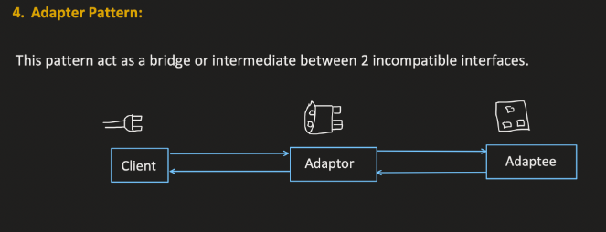

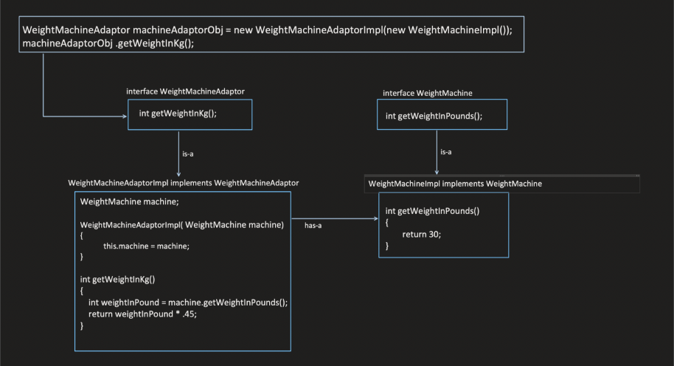

**Bridge Pattern**

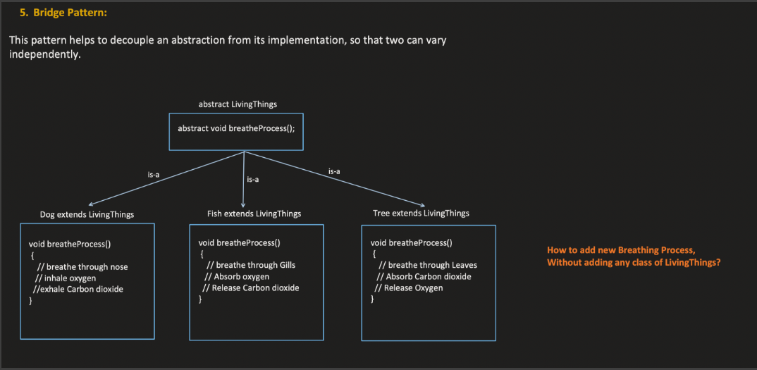

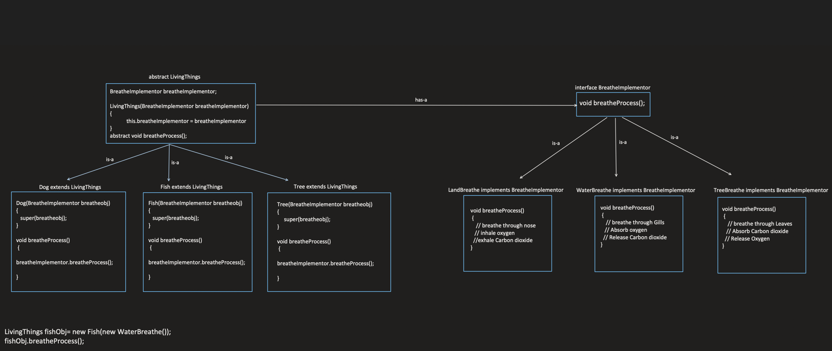

**Facade Pattern**

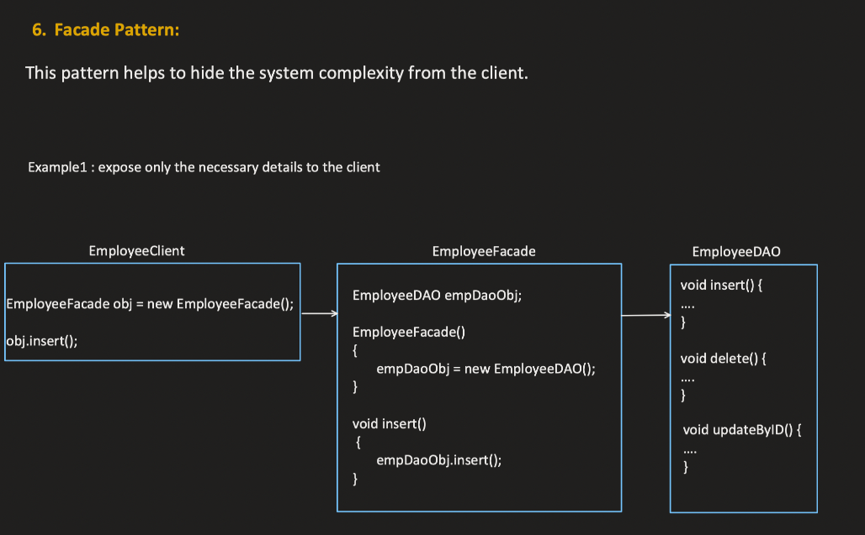

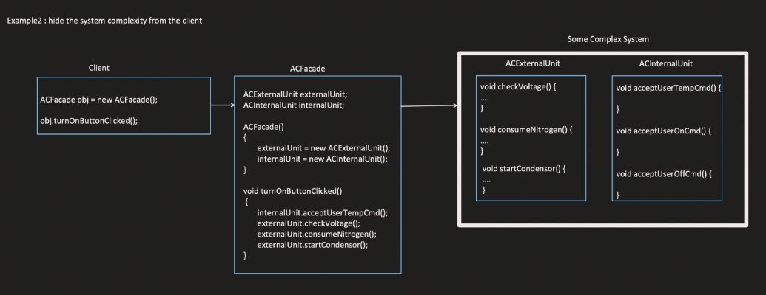

**Flyweight Pattern**

